**Task-1:**

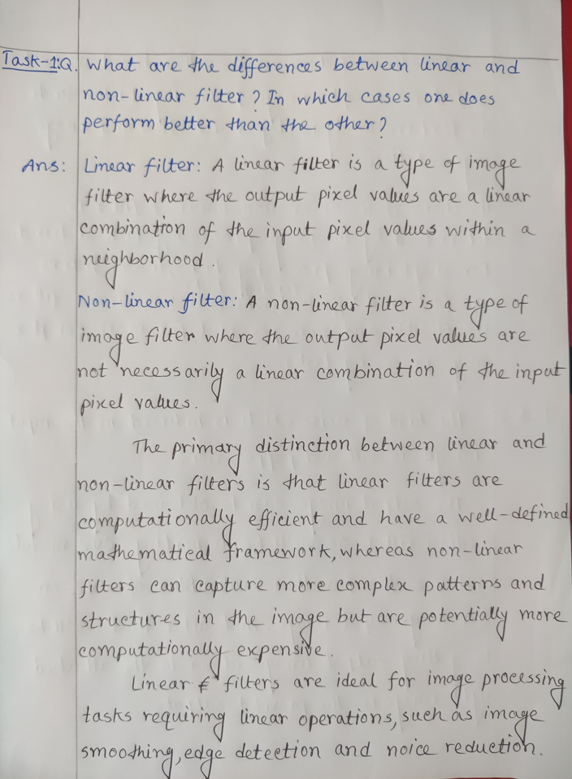

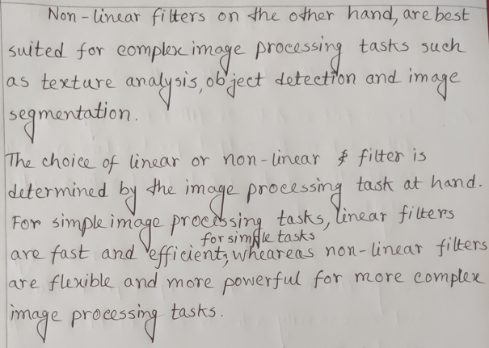

**Task-2:**

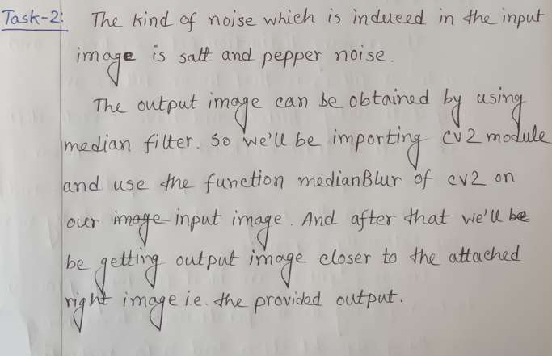

**The code of the Task-2 is:**

import cv2  
import numpy as np

input_img = cv2.imread('Input-2.png')  
grayed = cv2.cvtColor(input_img, cv2.COLOR_BGR2GRAY)  
filtered_img = cv2.medianBlur(grayed, 5)

cv2.imshow('Original', grayed)  
cv2.imshow('Filtered', filtered_img)  
cv2.waitKey(0)

**The Input:**

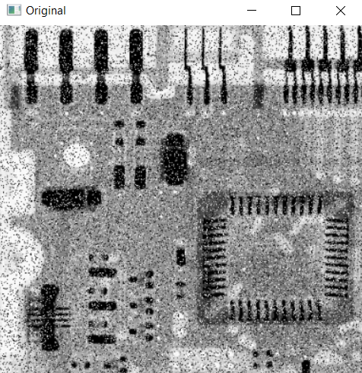

**The Output:**

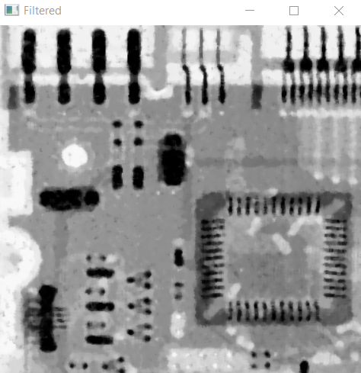

**Task-3:**

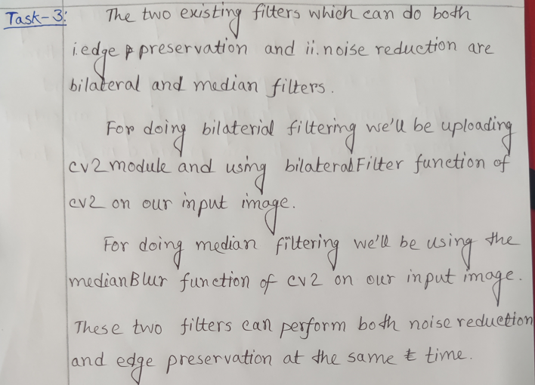

**The code of Task-3(Bilateral) is:**

import cv2  
import numpy as np

input_noise_img = cv2.imread('input-3.png')  
bilateral_img = cv2.bilateralFilter(input_noise_img, 20, 40, 100, borderType = cv2.BORDER_CONSTANT)

cv2.imshow('Original', input_noise_img)  
cv2.imshow('Bilateral', bilateral_img)  
cv2.waitKey(0)  
cv2.destroyAllWindows()

**The Input:**

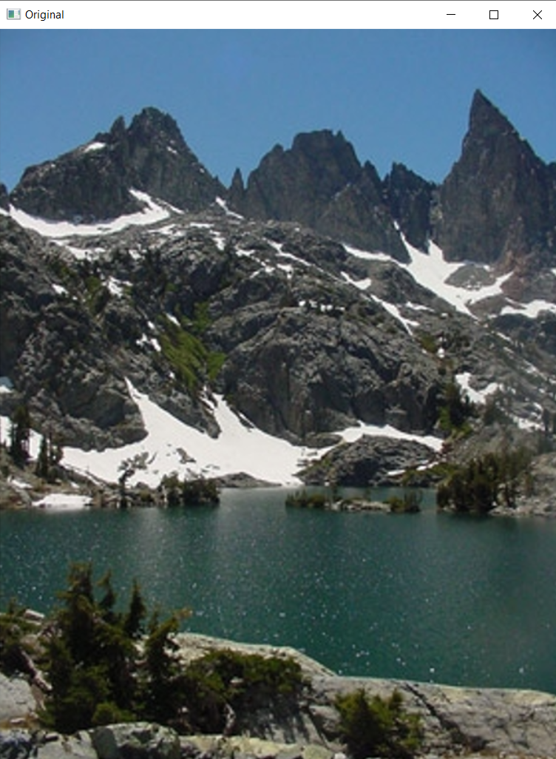

**The Output:**

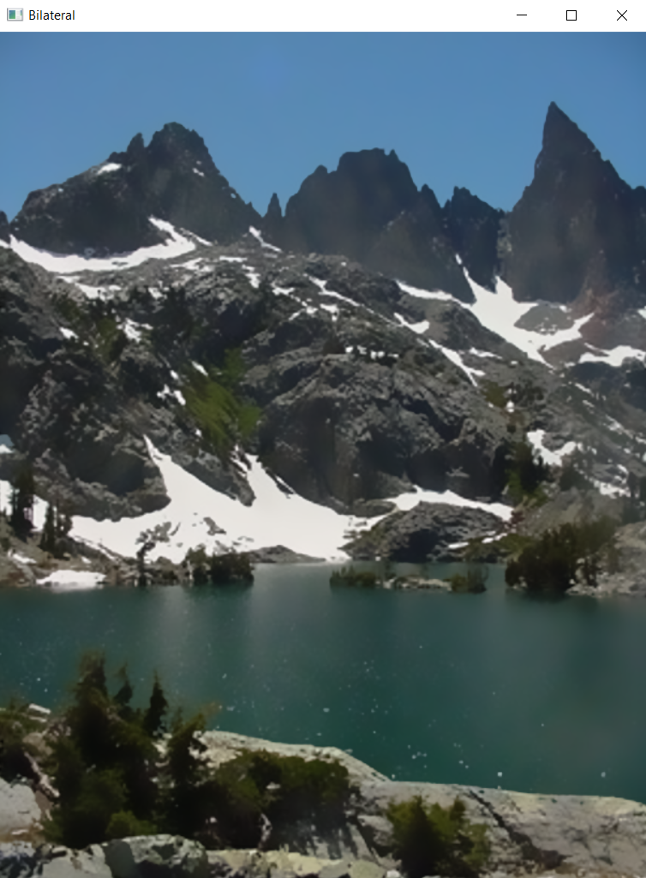

**The code of Task-3(Median) is:**

import cv2  
import numpy as np

input_noise_img = cv2.imread('input-3.png')  
median_img = cv2.medianBlur(input_noise_img, 7)

cv2.imshow('Original', input_noise_img)  
cv2.imshow('Median', median_img)  
cv2.waitKey(0)  
cv2.destroyAllWindows()

**The Input:**



**The Output:**

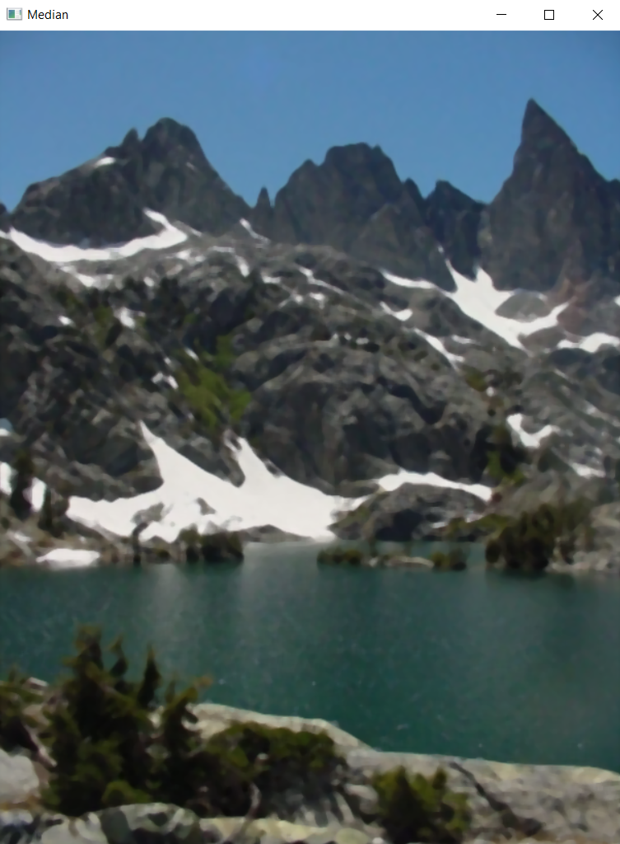

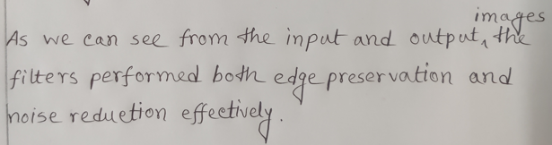

**Task-4:**

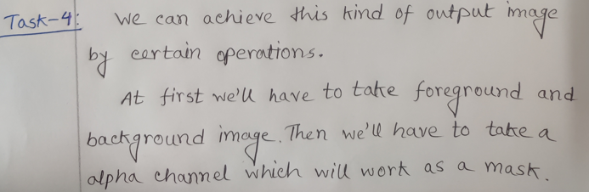

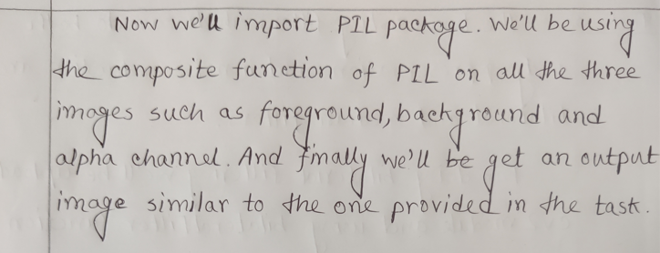

**The code of Task-4 is:**

import cv2  
import numpy as np

from PIL import Image

foregnd_img = Image.open('foregnd.png').convert('RGB').resize((600,600))  
backgnd_img = Image.open('backgnd.png').convert('RGB').resize((600,600))

masking = Image.open('alpha_chnl.png').convert('L').resize((600,600))

Image.composite(foregnd_img, backgnd_img, masking).save('Output.png')

out_img = cv2.imread('Output.png')  
cv2.imshow('Output Image', out_img)  
cv2.waitKey(0)  
cv2.destroyAllWindows()

**The Inputs:**

Background:

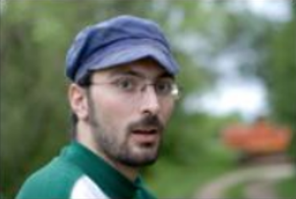

Foreground:

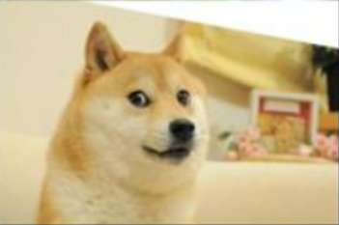

Alpha Channel:

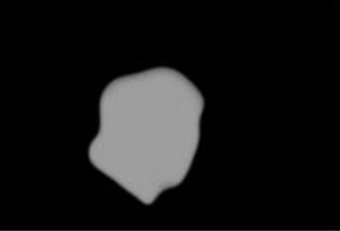

**The Output:**

